Topic 7: Credit Derivatives

Chapter 29: Introduction to Credit Derivatives

- Compare and contrast the three types of credit risk.

- Default risk
This is the risk that the issuer of a bond will not meet required interest or principal payments.
- Downgrade risk
Is the possibility that the credit rating of an asset/issuer is downgraded by a Nationally Recognized Statistical Rating Organization (NRSRO).
- Credit spread risk
This is the risk of increase in the spread between the yield of the risky asset and the yield of a risk-free benchmark security.

2. Describe two methods of measuring credit risk.

- Credit Ratings
Moody’s or Standard & Poor’s.
Baa and Ba is the dividing line between investment and speculative grade credit ratings made by Moody’s. A Nationally Recognized Statistical Rating Organization (NRSRO)
- Credit Risk Premiums
This is the difference between the yield on a risky asset and a comparable risk-free Treasury security

3. Describe 3 methods of managing credit risk.

- Underwriting Standards
This refers to a lender’s process of analyzing a borrower’s financial position and the industry a borrower operates in before deciding how much money to lend.
- Operating leverage
- Competitive pressures
- Earnings potential
- Diversification
Refers to making loans across multiple industries to reduce the lender’s risk that every loan in a portfolio will default at the same time.
- Asset Sales
Refers to the sale of loans to outside parties in order to remove the loan from the lender’s balance sheet. REMOVE the LOAN from the balance sheet.

4. Understand the diversification potential of credit risky investments.

Credit risky investments offer tremendous diversification for both stock and Treasury bond portfolios due to their low correlation with both asset classes.

- High yield bonds
- Leveraged load
- Distressed debt
- Emerging market bonds

5. Describe the high yield debt market.

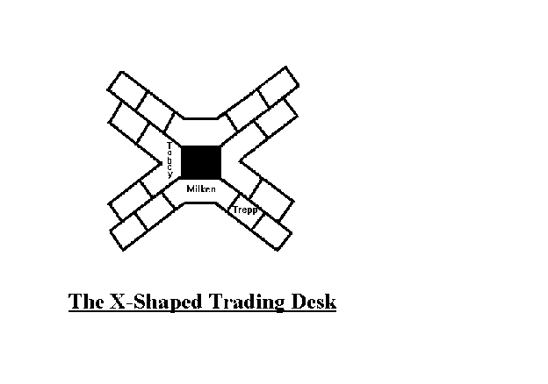

Note: “X-Shape Trading desk. Milken, Tobey, Trepp”

- High Yield debt is negatively skewed with fat tails.
- This indicates that high yield bonds have significant downside risk exposure as a result of downgrades, defaults, or widening of credit spreads. Because of the Negative Skew.
- High-yield bonds, or "junk" bonds, are corporate debt securities that pay higher interest rates because they have lower credit ratings than investment-grade bonds.
- These bonds have credit ratings below BBB- from S&P, or below Baa3 from Moody's.
- High-yield bonds offer investors higher interest rates and potentially higher long-run returns than investment-grade bonds but are far riskier.
- In particular, junk bonds are more likely to default and display much higher price volatility.

6. Describe the leveraged bank loan market.

- Leverage Bank Loans have the most consistent returns compared to high yield debt, emerging market debt, and distressed debt.
- Made up of loans to companies with a credit rating below investment grade, or loans that are priced at 150 basis points or greater spread over LIBOR.
- Leveraged loans are secured, high-yield bonds are unsecured. This means that if the company goes bankrupt, the leveraged loans are paid first. Loans also have stricter covenants that protect them, like preventing companies from issuing future debt senior to them.
- For this reason, historically recoveries upon default are 70% for leveraged loans versus 30% for high yield bonds.
The primary risks in the bank loan market are:
- Call risk
- Default risk
- Downgrade risk
- Spread risk

7. Compare and contrast revolvers with term loans.

Revolvers:
- Corporate bank loans that are legally committed line of credit are Revolvers
- Lines of credit that can accessed as necessary by the customer for a prearranged fee.
- Most revolvers are used to back commercial paper programs for financially stable companies.
- Revolving credit is a type of credit that does not have a fixed number of payments, in contrast to installment credit. Credit cards are an example of revolving credit used by consumers. Corporate revolving credit facilities are typically used to provide liquidity for a company's day-to-day operations.



Term loans:
- Term loans are fully funded commitments with fixed amortization schedules.
- They are typically used with companies that have lower credit ratings.
- Term loans are repriced periodically by adjusting the interest rate on the loan.
- This means that the term loan will have less sensitivity to interest rate risk and credit risk is the primary factor in determining the loan’s total return.

8. Describe the emerging markets debt market.

- Emerging debt market: MOST NEGATIVELY SKEWED
- Willingness to Pay: Political Risk
- Ability to Pay: Credit risk
- Negative skewness. Most excess kurtosis.
- Emerging debts markets have the most negative skew.
- Kurtosis = peakedness
- Emerging market bonds are debt instruments issued by developing countries, which tend to carry higher yields than government or corporate bonds of developed countries. Most of the benchmark EMBI index tracks emerging sovereign debt, with the rest in regional corporate bonds.

9. Describe the distressed debt market.

- Distressed securities are securities of companies or government entities that are either already in default, under bankruptcy protection, or in distress and heading toward such a condition.
- The most common distressed securities are bonds and bank debt. While there is no precise definition, fixed income instruments with a yield to maturity in excess of 1000 basis points over the risk-free rate of return (e.g. Treasuries) are commonly thought of as being distressed.
- A related category is stressed debt yielding between 600-800 basis points over Treasuries. Distressed securities often carry ratings of CCC or below from agencies such as Standard & Poors, Moodys, and Fitch.

10. List FOUR Advantages that credit derivatives provide.

- Isolation of credit risk
- Transfer of credit risk
- Providing liquidity to the market
- Transparency in credit pricing

11. Understand credit put options and credit call options.

- The Credit PUTS:
Provide a cash payment based on the value of the underlying bond, while credit CALL options provide cash payments in the form of additional coupon income.
- Credit CALL Options:
Allows the option holder to receive additional coupon income in the event of a credit rating downgrade.

- Frequently binary options
- Pay additional coupon income to the option holder if the credit event occurs but pay nothing if the credit event does not occur.
Credit PUT Options:
- If the reference asset has defaulted, the credit put buyer receives a payout.
- Comes either as European or American. If American, you want to exercise as soon as company is in default – otherwise, you are losing out on money.
- Have triggers. Falling below a stated minimum level of net worth, or a reduction in credit rating. Watch for questions which include ratings downgrades. From AA to Bb, for example.

12. Explain why an investor would purchase a credit linked note (CLN).

Credit Linked Note
- It is a bond issued with an EMBEDDED credit option.
- CLNs are issued based on a single reference asset, or a basket of multiple reference assets.
- The investor will receive a higher coupon payment as compensation for bearing the credit risk. HIGHER Than a traditional Bond.
- Know when it should be exercised.

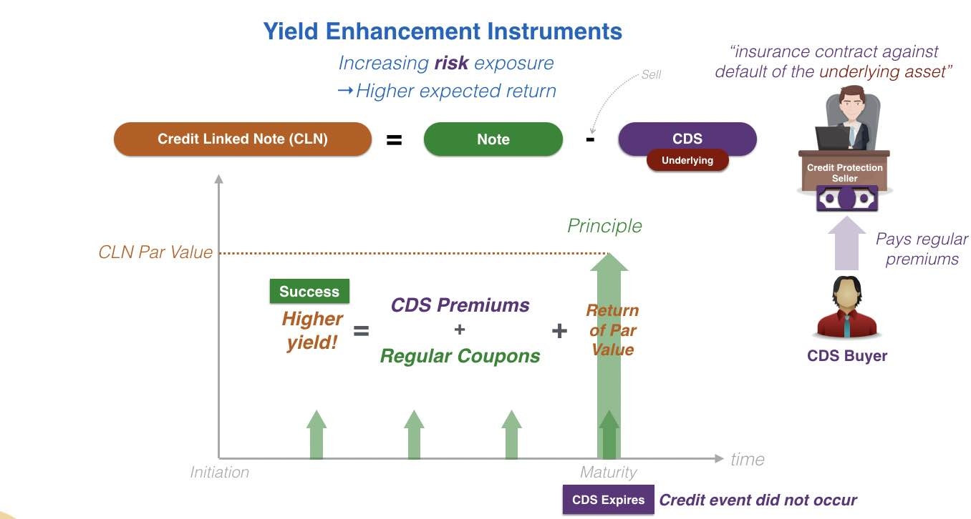

- A credit linked note (CLN) is a form of funded credit derivative. (So, it is also dependent on Credit). It is structured as a security with an embedded credit default swap (CDS) allowing the issuer to transfer a specific credit risk to credit investors. The issuer is not obligated to repay the debt if a specified event occurs. This eliminates a third-party insurance provider.
- It is issued by a special purpose company or trust, designed to offer investors par value at maturity unless the referenced entity defaults. In the case of default, the investors receive a recovery rate.
- The trust will also have entered into a default swap with a dealer. In case of default, the trust will pay the dealer par minus the recovery rate, in exchange for an annual fee which is passed on to the investors in the form of a higher yield on their note.
- The purpose of the arrangement is to pass the risk of specific default onto investors willing to bear that risk in return for the higher yield it makes available. The CLNs themselves are typically backed by very highly-rated collateral, such as U.S. Treasury securities.
- The Italian dairy products giant, Parmalat, notoriously dressed up its books by creating a credit-linked note for itself, betting on its own credit worthiness.
- In Hong Kong and Singapore, credit-linked notes have been marketed as "minibonds" and sold to individual investors. After Lehman Brothers, the major issuer of minibond in Hong Kong and Singapore, filed for bankruptcy in September 2008, many retail investors of minibonds claim that banks and brokers mis-sold minibonds as low-risk products. Many banks accepted minibonds as collateral for loans and credit facilities.
Example:
- A bank lends money to a company, XYZ, and at the time of loan issues credit-linked notes bought by investors.
- The interest rate on the notes is determined by the credit risk of the company XYZ. The funds the bank raises by issuing notes to investors are invested in bonds with low probability of default.
- If company XYZ is solvent, the bank is obligated to pay the notes in full. If company XYZ goes bankrupt, the noteholders/investors become the creditor of the company XYZ and receive the company XYZ loan. The bank in turn gets compensated by the returns on less-risky bond investments funded by issuing credit linked notes.

13. Compare and contrast the cash flows of a total return credit swap (TRS) for the swap buyer with those for the swap seller.

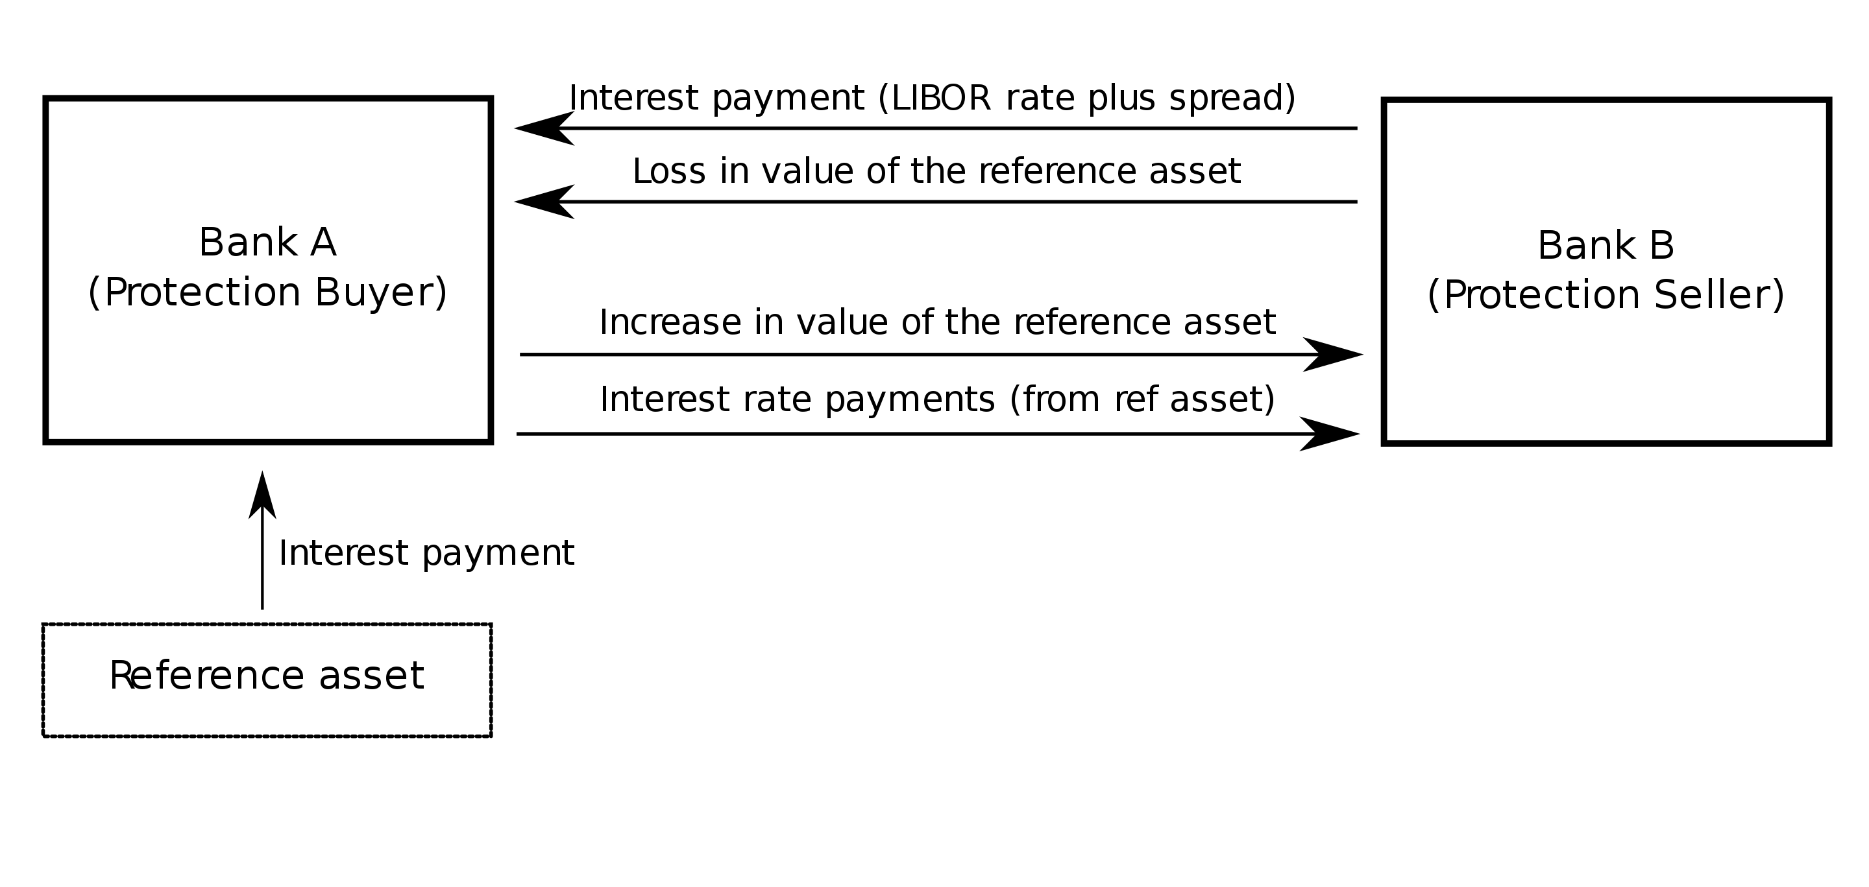

- It allows the holder of the asset to eliminate credit risk (and other risks) without having to sell the asset.
- Conversely, the buyer of a TRS gains exposure to the underlying asset without having to purchase it.

BUYER
- The buyer for the TRS (also called the receiver) will receive the total return of the reference asset, which included capital gains/losses and any flows such as coupons, interest, or dividends over the life of the swap.
- Since the buyer of the swap receives any gain or loss from the underlying asset, the swap buyer assumes the asset’s credit risk.
- In exchange for receiving the total return, the swap buyer pays LIBOR plus a spread.
SELLER
- The cash flows for the seller of the TRS (also called the TRS payer) net out to LIBOR plus a spread.
- The swap seller retains ownership of the reference asset which means the swap seller must continue to finance the reference asset in the form of borrowing or opportunity costs.
- However, since cash flows are passed through to the swap buyer, the remaining cash flow is LIBOR plus the spread.
- As a result of entering into the swap, even though the swap seller still owns the reference asset, the asset’s credit risk exposure is effectively passed to the swap buyer.

14. Compare and contrast a total return credit swap (TRCDS) with a credit default swap (CDS)

Total Return Credit Swap (TRCDS).
- In the case of a total return credit swap, the total return of the reference asset is passed through to the swap buyer regardless of a credit event.

Credit Default Swap (CDS)
- Can be viewed as protection or insurance against default on an underlying credit instrument.
- The party that sells the protection receives a periodic fee in exchange for a commitment to stand behind the underlying bond or loan should the issuer default
- In the case of a CDS, the contingent payment is only made if the credit event occurs.
- The development of the CDS market has even led to indices of CDSs now available for trading. The International Index Company’s ITraxx index and the Dow Jones CDX Index.

15. List FIVE types of TERMS negotiated by parties to a CDS.

- CDS spread
- Contract size and maturity
- Payment trigger events
- Method of settlement
- Choice of Assets to deliver

16. List SIX kinds of trigger events provided by the International Swaps and
Derivatives Association (ISDA).

BR ROOF
- Bankruptcy
- Repudiation/Moratorium

- Restructuring
- Obligation Acceleration
- Obligation Default
- Failure to Pay

17. List FOUR types of risks associated with credit derivatives.

Operate Parties when your Liquids are Priced
- Operational Risk
- Counterparty Risk
- Liquidity Risk
- Pricing/model risk

Chapter 30: Collateralized Debt Obligations (CDOs)

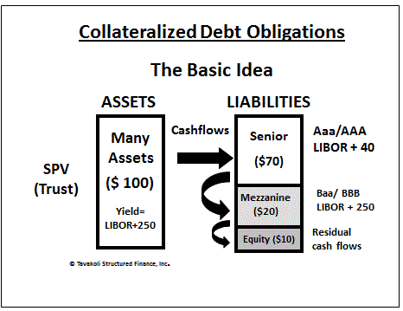

What Is a Collateralized Debt Obligation (CDO)?
A collateralized debt obligation (CDO) is a complex structured finance product that is backed by a pool of loans and other assets and sold to institutional investors. A CDO is a particular type of derivative because, as its name implies, its value is derived from another underlying asset. These assets become the collateral if the loan defaults.

1. Explain factors impacting the growth (or contraction) in the collateralized debt obligation (CDO) market

- CDO give investors access to a diversified pool of credit risk assets
- Credit tranching allows investors to select specific credit risk exposures
- CDOs gives banks an effective way to manage credit risk
- Fees collected by asset manager and underwriter

2. Compare and contrast the structure of balance sheet CDOs with arbitrage CDOs.

Balance sheet CDOs are used primarily by banks and insurance companies as a means to manage assets on their balance sheet.

When an entity chooses to issue a balance sheet CDO, they typically have one of three goals:

- Reducing credit exposure to a certain client or industry
- Reducing regulatory capital chargers
- Capital infusion

Arbitrage CDOs are used primarily by money managers, where the motivation is to generate an arbitrage profit created by the spread between the return on the collateral pool and the return paid to investors in the CDO tranche securities.

Like balance sheet CDOs, arbitrage CDOs can be cash funded or created synthetically through the use of crhedit derivatives.

b. Cash funded CDO with synthetic CDOs.

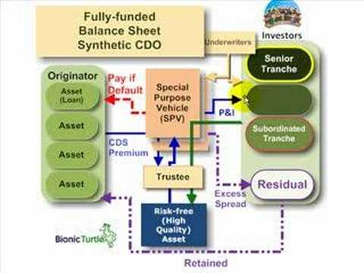

- The assets aren’t sold. Instead, the bank purchases CREDIT PROTECTION with CDSs.
- In a synthetic balance sheet CDO, the SPV does not invest in the underlying assets.
- Instead, the SPV gains exposure to the assets by using credit derivatives.
- Synthetic can be either a balance sheet or arbitrage deal.
- Typically, the total return profile of the basket of loans or other assets is transferred to the SPV through the use of a credit default swap, or a credit return swap.

c. Cash flow CDO with market value CDOs.

Cash flow CDO
- These CDOs depend solely on the cash flows generated from the collateral pool to repay the securities sold by the CDO.
Market Value Arbitrage CDOs
- These CDOs depend on the periodic sale of collateral assets to generate cash flows to meet the CDO tranches obligations.
- Market value CDOs do not match the payment schedules of the collateral and CDO securities. Instead, the return to CDO investors is linked to the market value of the underlying collateral, and the investment manager actively sells assets to generate cash flows to repay the CDO investors.

d. Funded with unfunded CDOs

- Unfunded CDOs allow investors to gain credit exposure through a pure CDS, where the investor receives payments as a credit protection seller and must pay the CDO issuer if the underlying CDO collateral suffers credit losses.

3. Explain how special purpose vehicles (SPV) work in the CDO market.

- SPVs are used for CDOs. This makes the SPV bankruptcy remote because it is completely separate legal entity.

4. Describe the structure of a cash funded balance sheet CDO.

- The seller of the assets is typically a bank that wants to remove a portion of its loan portfolio from its balance sheet.
- The bank will construct a CLO SPV, and the SPV will hold the actual securities that are used to generate payment to the tranches.
- The term cash funded means that the CDO is constructed by the actual sale of transfer of assets to the SPV

5. Calculate the net gain (or loss) of a synthetic balance sheet CDO using a total return swap (TRS) to the bank sponsoring a credit loan obligation (CLO) trust.

6. Explain why synthetic CDOs using credit default swaps (CDSs) are often called correlation products

- Today, most synthetic balance sheet CDOs are constructed using a credit default swap (CDS).
- Under the terms of the CDS, the bank makes periodic payments to the CDO trust, which reflects the insurance premiums that the bank pays to obtain credit protection.
- Synthetic CDOs using credit default swaps are often called correlation products because the CDS exposure is tied to the default of more than one bank loan.
- It will take multiple loan defaults to trigger the terms of the CDS.
- Therefore, the job of the CDO manager is to structure the CDS to minimize correlation risk so that multiple loads are unlikely to default at the same time.

7. Identify key benefits to banks from CLOs.

- Reducing risk based regulatory capital requirements
- Increasing capacity for additional loans
- Improving ROA and ROE
- Reducing credit concentrations to specific industries
- Maintain positive customer relations
- Competitive position among investors

Synthetic CDOs offer the ability to use leverage to enhance returns. A cash funded CDO does not use leverage. It simply passes through the cash received from the collateral to the securities in the CDO structure.

8. Compare and contrast cash flow arbitrage CDOs to market value arbitrage CDOs.

- Cash flows depend solely on the cash flows generated from the collateral pool to repay the securities sold by the CDO.

- Market value arbitrage CDOs depend on the periodic sale of collateral assets to generate cash flows to meet the CDO tranches obligations.

9. Describe synthetic arbitrage CDOs.

Synthetic CDO:

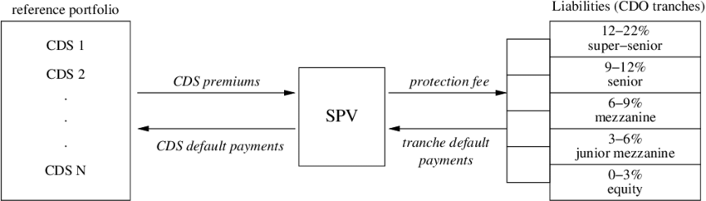

Use credit derivatives to transfer the risk exposure of a portfolio of assets without any change in the legal ownership of the assets.

- Payments are typically made quarterly, the underlying collateral must be market to market, which exposes the CDO security holder to market value fluctuations as well as default risk
- Can be either a balance sheet or arbitrage deal
- Avoids the difficulty that can result from transferring assets.
- Absorbs the economic risks of its reference credit exposures.
- Like creating a combo to go long or short a stock. Synthetics.
- Fewer administrative costs
- Can benefit from leverage
- Most similar to a market value arbitrage CDO.

Synthetic CDOs offer the ability to use leverage to enhance returns. A cash funded CDO does not use leverage. It simply passes through the cash received from the collateral to the securities in the CDO structure.

10. Calculate the profits from an arbitrage CDO TRUST.

- Calculate annual cash inflows:
- 8% on 300 million of high yield bonds
- Arbitrage CDOs accumulate assets from the proceeds of obligation issuance in order to meet the credit spread differential between the high-yield securities that form the collateral (the rate of return on the assets acquired by the CDO) and the low-yield liabilities represented by the rated CDO securities (the funding cost of the liabilities issued by the CDO).
- Arbitrage CDOs are usually issued by investment banks, investment management boutiques, asset and portfolio managers, insurance companies, and other similar entities.

Chapter 31: Risks and New Developments in CDOs

Describe the nature of the following new developments in CDOs:

a. Distressed debt CDOs.

- Uses distressed debt (securities already in default or expected to defaults).
- The appeal of the CDO structure is the ability to provide a series of tranches of collateralized securities that can have an investment grade credit rating even though the underlying collateral in the DDCO is mostly distressed debt.
- Main supplier is banks

b. Hedge fund CDOs (collateralized fund obligation)

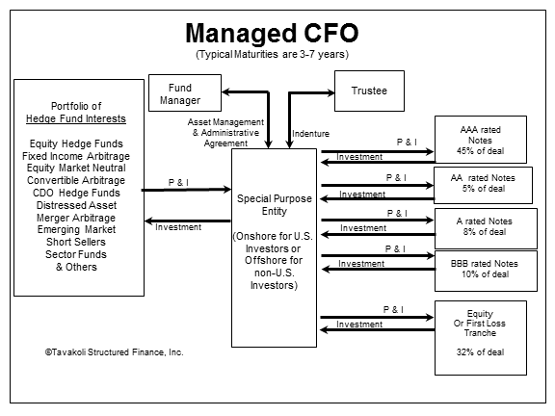

- These are backed by the investments of the hedge fund
- The use of hedge funds as collateral for a CDO structure is a rapidly growing area of the market and is often referred to by the term collateralized fund obligation (CFO).

c. Collateralized Commodity Obligations. CCOs

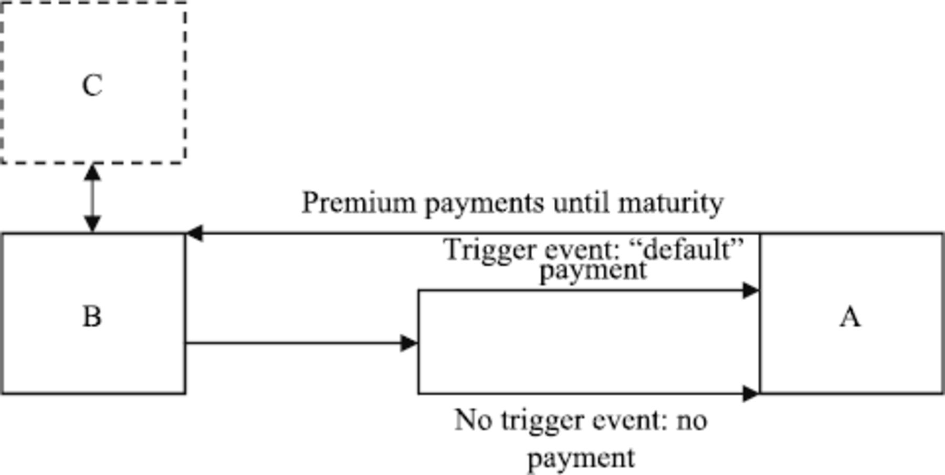Hit a certain price level.

- In early 2005, Barclays Capital launched the first collateralized commodity obligation.
- The underlying assets are often Commodities Trigger Swaps (CTS).
- Similar to credit default swaps in that certain trigger events cause a payment to be made between swap counterparties.
- However, for CTS the triggers are based on a commodity index hitting a certain price level.
- Portfolio construction rules may be needed to earn high credit ratings.

d. private equity CDOs.

- These are collateralized by investment in private equity funds.
- The appeal to investors is the ability to access the private equity asset class through securities that have an investment grade rating as a result of credit enhancements from the CDO structure.

e. single tranche CDOs.

- There is only one tranche in the CDO’s capital structure.
- Uses a credit default swap like a normal synthetic CDO
- The structure is also referred to as a “CDOs on demand” or “bespoke CDOs”
- The single tranche CDO works like a normal synthetic CDO by using a CDS to transfer risk exposure.
- The Advantage of a single tranche structures that it is customizable for the investor.
- Investors have control over collateral composition, maturity, and credit rating.
- There is no waterfall cash flow pattern as all cash flows flow to the single tranche CDO investor

f. CDO squared

- CDO squared = invests in other CDOs as part of its collateral pool. Sort of like doubling down.

2. Identify key risks associated with CDOs.

- Default risk of the underlying collateral
- Financial Engineering Risk
- Downgrade Risk
- CDO default rates
- Difference in periodicity
- Difference in payment dates
- Basis risk. When the index used for the determination of interest earned on the CDO collateral is different from the index used to calculate the interest on the CDO trust securities.
- Spread compression
- Yield Curve risk
- WARF vs. WAS

 Stan O’Neal

On September 5, 2008 Goldman Sachs downgraded Merrill Lynch's stock to "conviction sell" and warned of further losses at the company. Bloomberg reported in September 2008 that Merrill Lynch had lost $51.8 billion on mortgage-backed securities as part of the subprime mortgage crisis.

- Example is Merrill Lynch. CDO losses amounted to 25% of Merrill’s total profits earned since it went public in 1971.
- Lone Star took the CDO assets from the Merrill Lynch Balance Sheet.
- 14 Billion lost by Merrill.

3. Discuss the implications of the Weighted Average Rating Factor (WARF) and
Weighted Average Spread (WAS) over the CDO.

 Note: “Worf credit”

- The WAS measures the average amount of income the CDO collateral pool is earning in excess of LIBOR.
- The WARF measures the average credit rating of the collateral contained in the CDO trust.
- Increasing credit risk increases both the WAS and the WARF.
There is always a conflict between maintaining a high weighted average rating factor (WARF) and maintaining a high weighted average spread (WAS) over LIBOR which creates a challenge for the If you manager.
If you lower (WARF = Credit) then you make (WAS) higher.

__________________________________________________________________
Know the following:
- Calculate hurdle rate,
- CLO calculations,
- Due diligence (there were a lot of questions – all Anson stuff).
- A country visiting where there are stricter laws. Merger Arb skews and convergence.
- Excess kurtosis.
- Survivorship bias.
- SEC, CFTC, NFA,
- CTAs vs. CPS and who registers.
- E(St) > F – futures formula.
- Learn more about TIPs.
- Stress testing.
- CFTC and what they do exactly.
- Trend following.
- Long/short selling.
- 0 skew.
- With risk Arb.
- Central Tendency.
- Illiquidity.
- Lower volatility.
- Questions about b in the regression equation.
- FAMA, French, skew etc. on large caps and what it is.
- Return patterns for LBO’s.
- Gifts ethics question.
- Expected rate of return.
- DCF and real estate.
- What is like kind for different countries.
- Annuity monthly rates.
- Beta expansion risk – created from short selling.
- Single factor model.
- Modified VaR.
- What exactly is co-skewness.
- CL notes and when they should be exercised.

Know the following:
- LBO calculations
- Currency futures - yen vs dollar
- CDO market vs arbitrage
- Details of COO
- Bankruptcy questions
- Toxic Pipes – details of the death spiral
- DIP – debtor in possession financing
- Mezzanine debt definitions etc.
- Leverage Build up
- Agency Costs
- CPO getting a CTA
- DJ AIG – everything about it. Which ones include Financials
- Margin – variation margin – maintenance margin
- Double Alpha strategy
- Hot issue securities

